User Manual

---oOo---

1. Homepage 2
2. Gallery Page 4
3. Category Page 5
4. About 6
5. Contact 7
6. Site Map 8

Home Page

Home page is main page when you access our website:

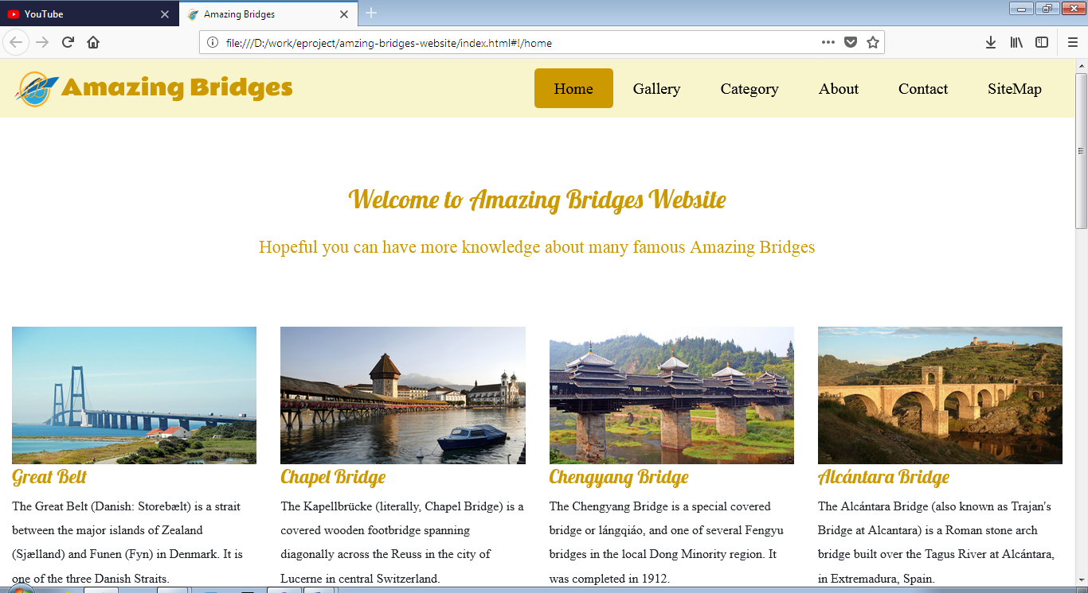

If you want to view any bridge you can click it and it will show for you

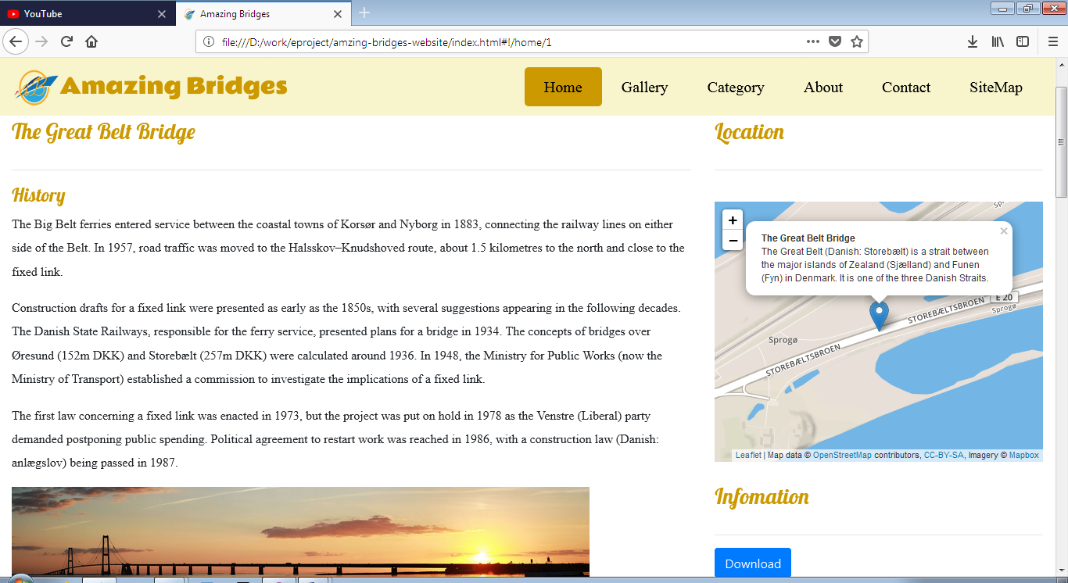

If you want to download document to offline-reading only need click download button.

Flight Aware will show you live flight if you want to go this bridge.

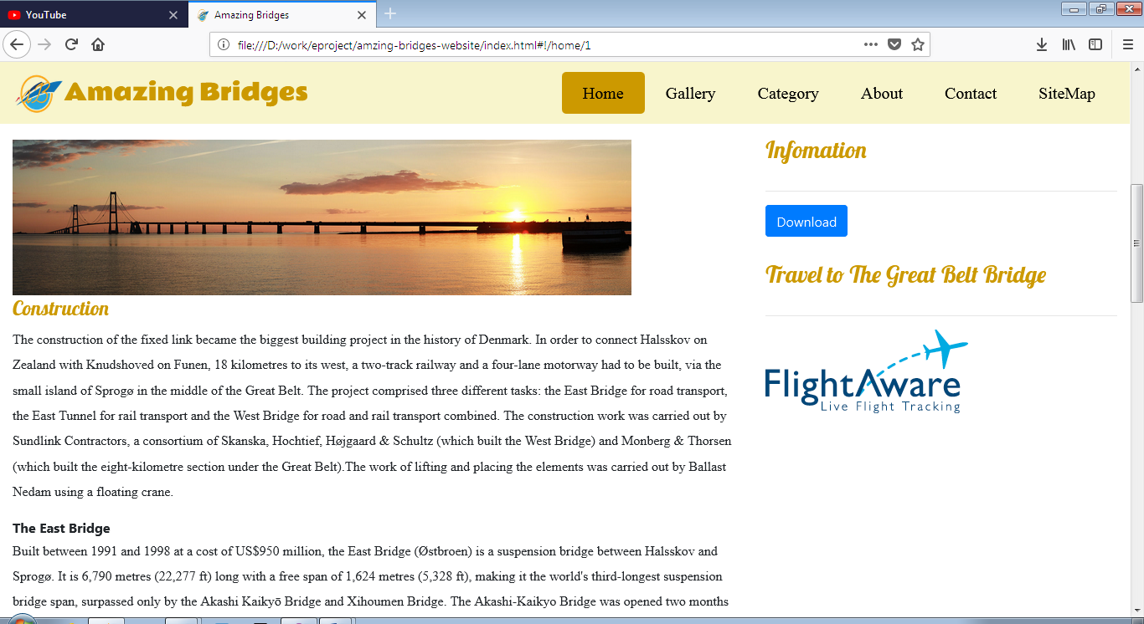

Gallery Page

Gallery Page is slideshow picture for you can see the beautiful bridges.

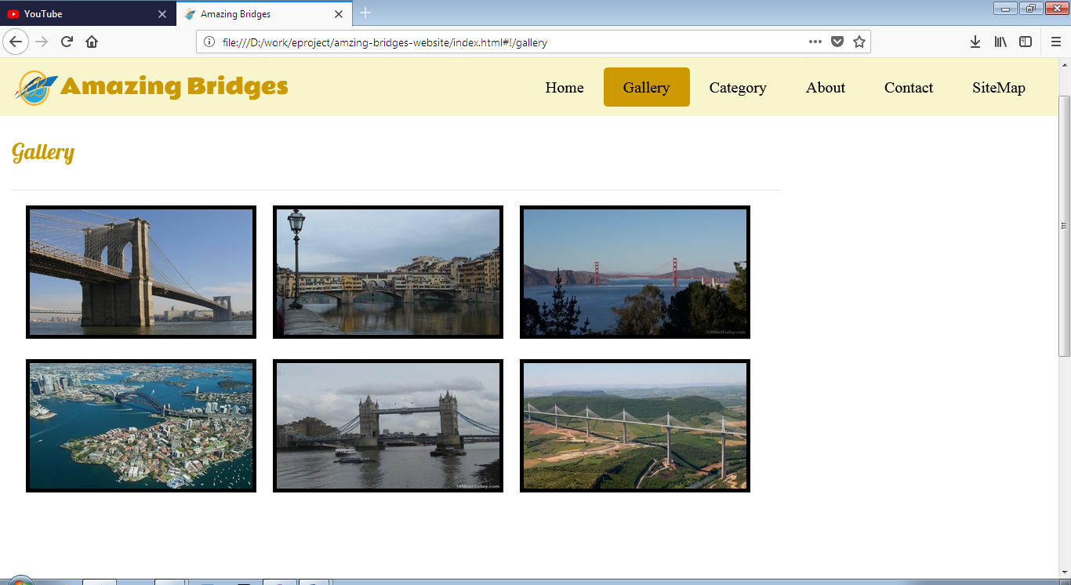

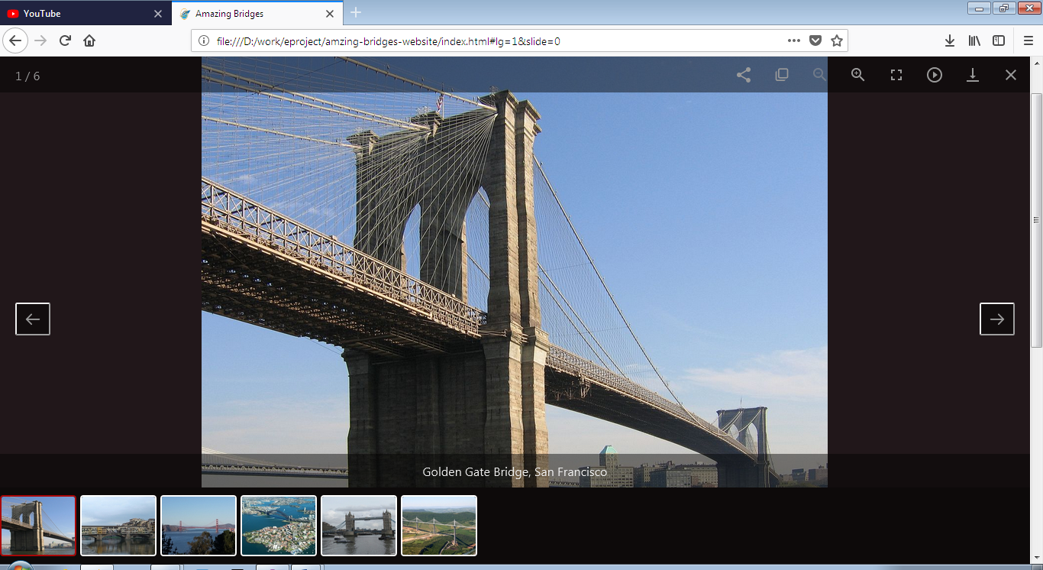

Category

Tallest Bridge is The Millau Viaduct

Longest Bridge is Danyang–Kunshan Grand Bridge

VietNam Bridge is Cầu khỉ

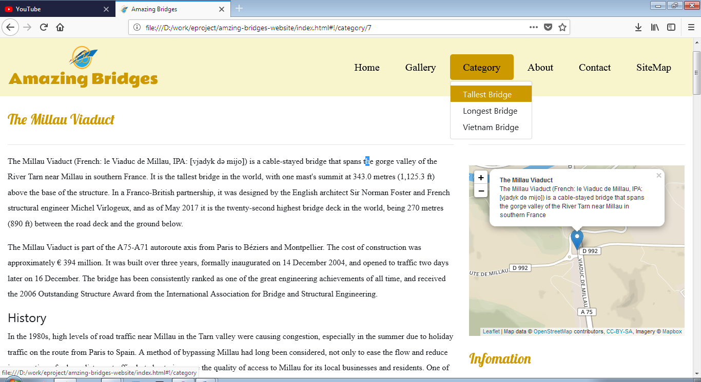

About

Developer team information you can find here

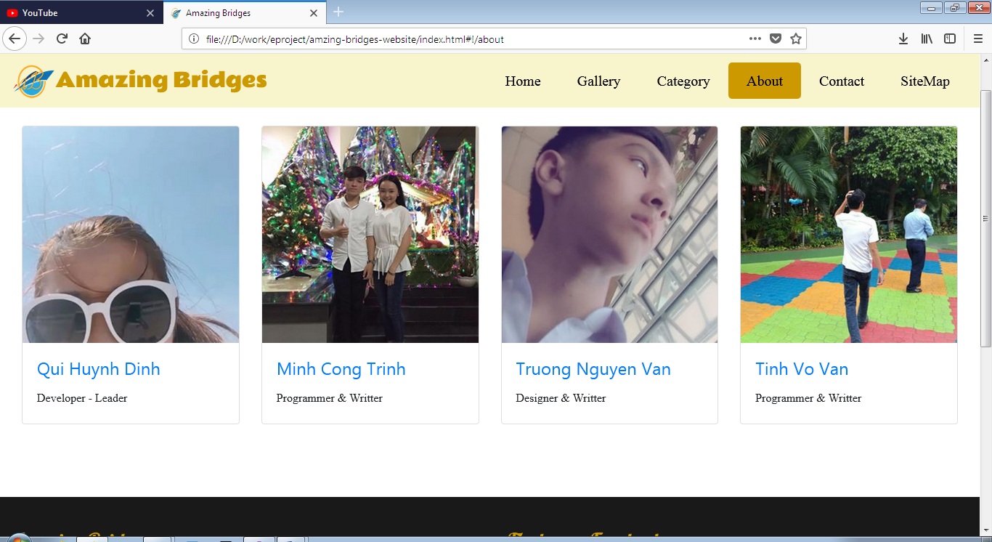

Contact

Need support, you can go there to contact us. We will recived any your feedback to improve this website.

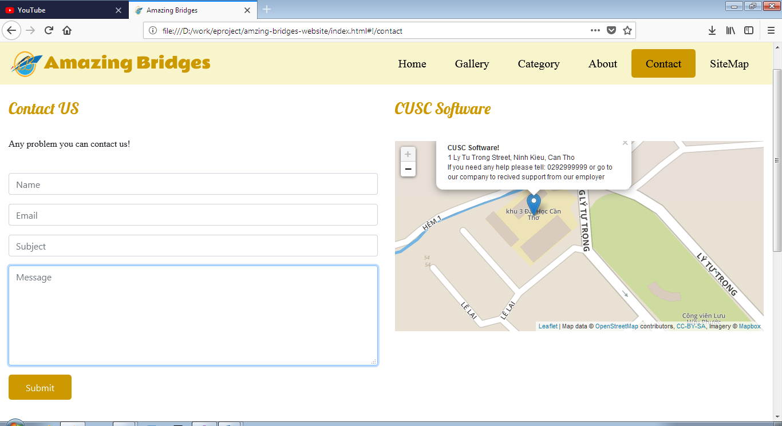

Site Map

Any link you want to find

